Steps Summary:

* Set up MariaDB in windows.
* Create databases and tables using SQL commands.
* Load data from CSV files into the tables.
* Execute SQL queries for exercises.
* Capture screenshots as proof for each step.
* Compile screenshots and documentation into the report.

**Steps to Create a Database:**

**Access MariaDB:** Open the MariaDB command-line interface or connect to your MariaDB server using a tool like phpMyAdmin or MySQL Workbench.

**Execute SQL Command:** Once connected, execute the following SQL command to create the database:

* CREATE DATABASE university_db;

This command creates a new database named university_db.

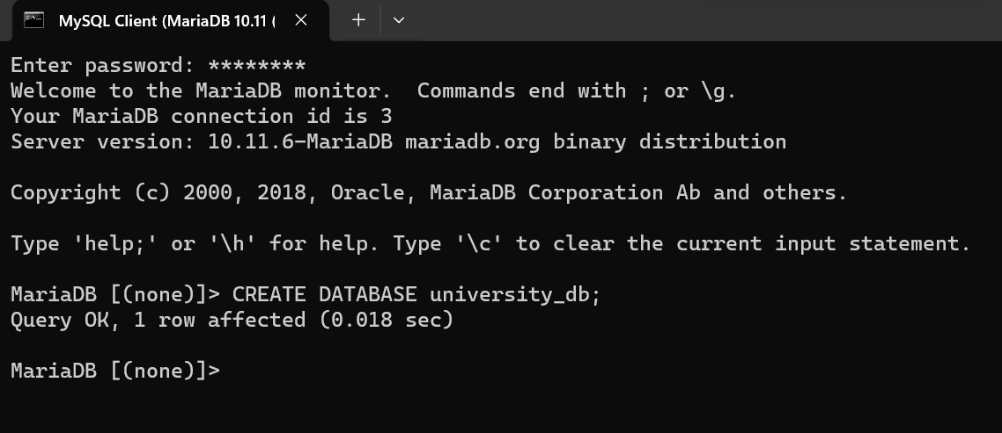

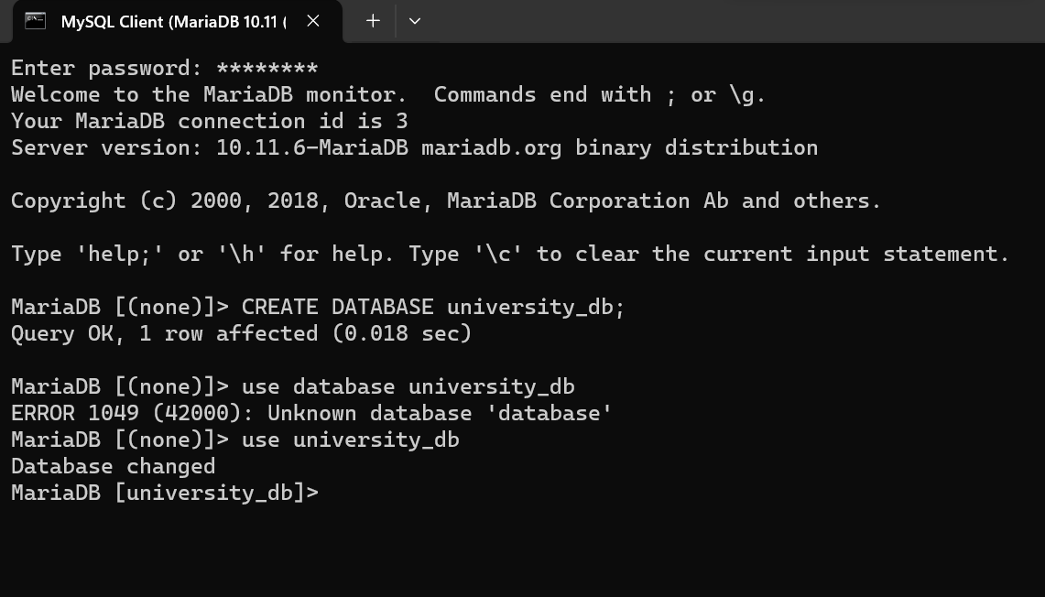

**Entity-Relationship Diagram (ERD):**

Entities and Attributes:

**Student**:

StudentID (Primary Key)

Name

Email

Address

**Course**:

CourseID (Primary Key)

Title

Description

**Enrollment**:

EnrollmentID (Primary Key)

StudentID (Foreign Key referencing Student)

CourseID (Foreign Key referencing Course)

EnrollmentDate

**Instructor**:

InstructorID (Primary Key)

Name

Email

**Department**:

DepartmentID (Primary Key)

Name

Location

Relationships:

**Student** and **Enrollment**: One student can have multiple enrollments (One-to-Many).

**Course** and **Enrollment**: One course can have multiple enrollments (One-to-Many).

**Instructor** and **Course**: One instructor can teach multiple courses (One-to-Many).

**Department** and **Instructor**: One department can have multiple instructors (One-to-Many).

ERD Diagram:

Create Scripts:

CREATE TABLE Student (StudentID INT PRIMARY KEY, Name VARCHAR(100), Email VARCHAR(100), Address VARCHAR(255));

CREATE TABLE Course (CourseID INT PRIMARY KEY, Title VARCHAR(100), Description TEXT);

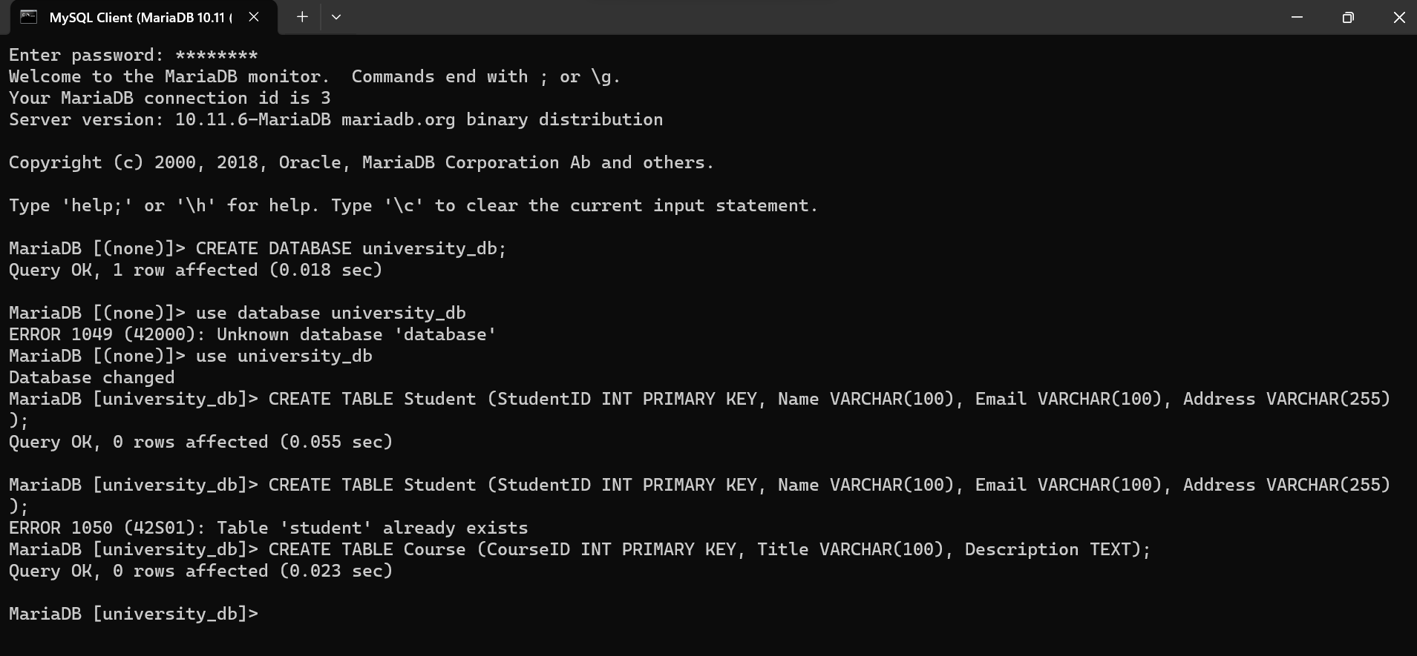

CREATE TABLE Enrollment (EnrollmentID INT PRIMARY KEY, StudentID INT, CourseID INT, EnrollmentDate DATE, FOREIGN KEY (StudentID) REFERENCES Student(StudentID), FOREIGN KEY (CourseID) REFERENCES Course(CourseID));

CREATE TABLE Instructor (InstructorID INT PRIMARY KEY, Name VARCHAR(100), Email VARCHAR(100));

CREATE TABLE Department (DepartmentID INT PRIMARY KEY,Name VARCHAR(100), Location VARCHAR(100));

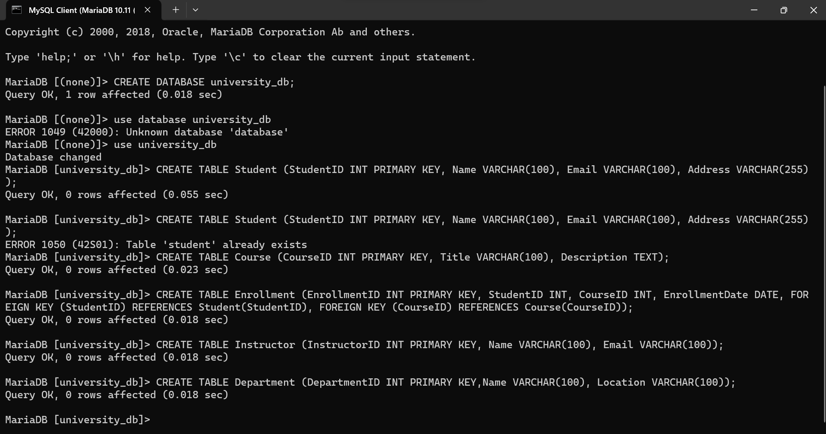

**STUDENT**

# Sample data for Student entity

student_data = [

['StudentID', 'Name', 'Email', 'Address'],

[1, 'John Doe', 'john@example.com', '123 Main St'],

[2, 'Alice Smith', 'alice@example.com', '456 Elm St'],

[3, 'Bob Johnson', 'bob@example.com', '789 Oak St']

]

LOAD DATA INFILE 'student_data.csv' INTO TABLE student

FIELDS TERMINATED BY ',' ENCLOSED BY '"'

LINES TERMINATED BY '\r\n'

IGNORE 1 LINES;-- Skip the header if present in the CSV file

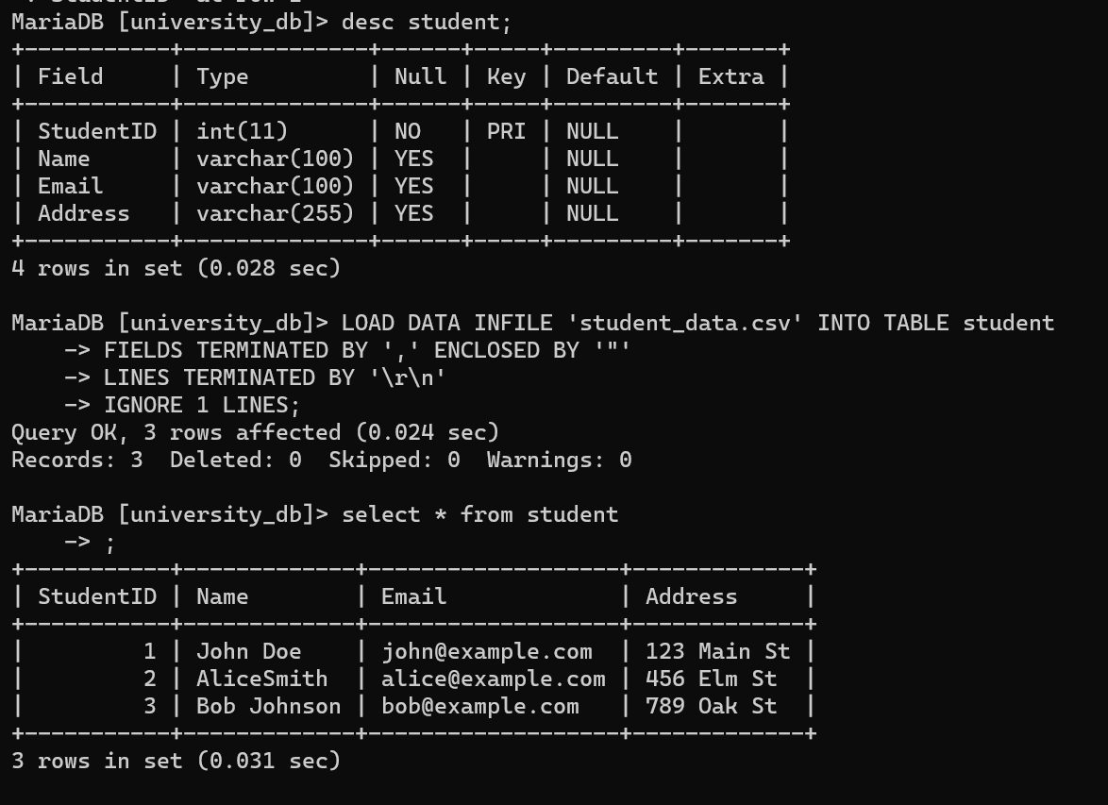

**COURSE:**

# Sample data for Course entity

course_data = [

['CourseID', 'Title', 'Description'],

[101, 'Mathematics', 'Introduction to Algebra'],

[102, 'History', 'World History: Ancient Civilizations'],

[103, 'Computer Science', 'Programming Fundamentals']

]

# Writing data to Course CSV file

LOAD DATA INFILE 'course_data.csv' INTO TABLE course

FIELDS TERMINATED BY ',' ENCLOSED BY '"'

LINES TERMINATED BY '\r\n'

IGNORE 1 LINES; -- Skip the header if present in the CSV file

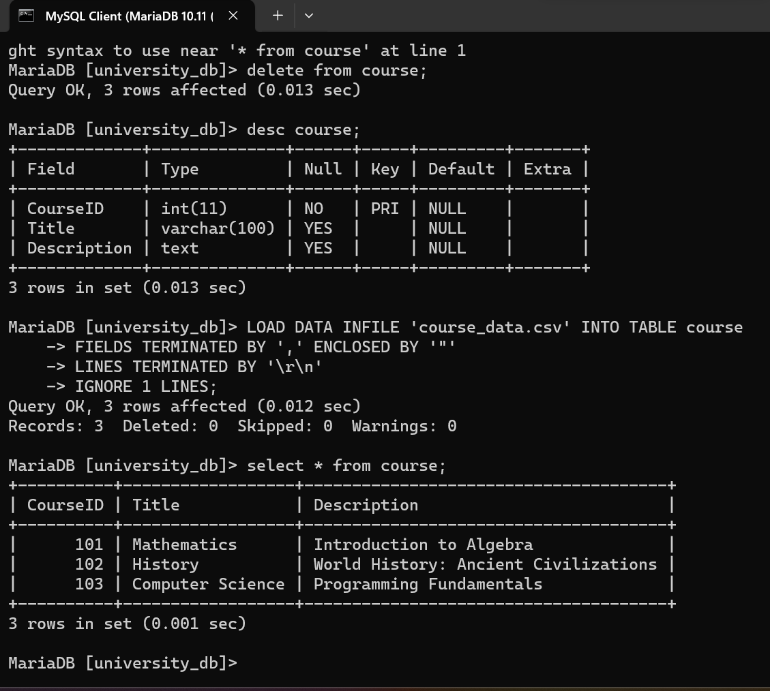

**ENROLMENT**

# Sample data for Enrollment entity

enrollment_data = [

['EnrollmentID', 'StudentID', 'CourseID', 'EnrollmentDate'],

[1, 1, 101, '2023-01-15'],

[2, 2, 102, '2023-02-20'],

[3, 3, 103, '2023-03-25']

]

# Writing data to Enrollment CSV file

LOAD DATA INFILE 'enrollment_data.csv' INTO TABLE enrollment

FIELDS TERMINATED BY ',' ENCLOSED BY '"'

LINES TERMINATED BY '\r\n'

IGNORE 1 LINES;

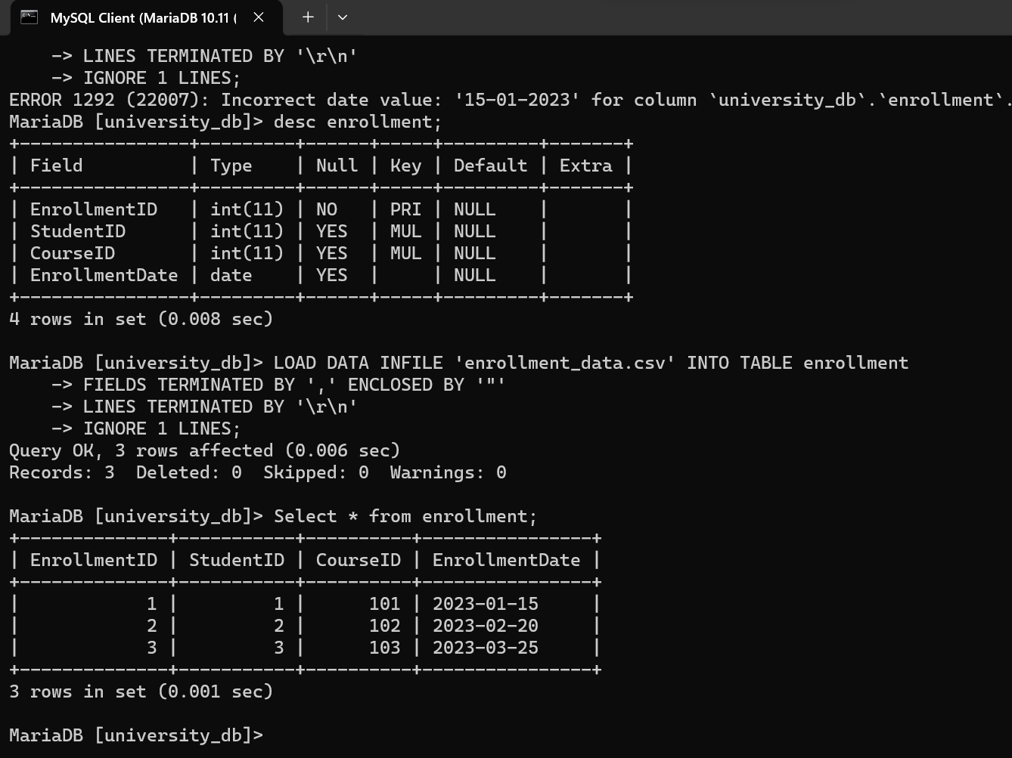

**INSTRUCTOR**

#Sample data for Instructor entity

instructor_data = [

['InstructorID', 'Name', 'Email'],

[1, 'Dr. Smith', 'smith@example.com'],

[2, 'Prof. Johnson', 'johnson@example.com'],

[3, 'Dr. Brown', 'brown@example.com']

]

# Writing data to Instructor CSV file

LOAD DATA INFILE 'instructor_data.csv' INTO TABLE Instructor

FIELDS TERMINATED BY ',' ENCLOSED BY '"'

LINES TERMINATED BY '\r\n'

IGNORE 1 LINES;

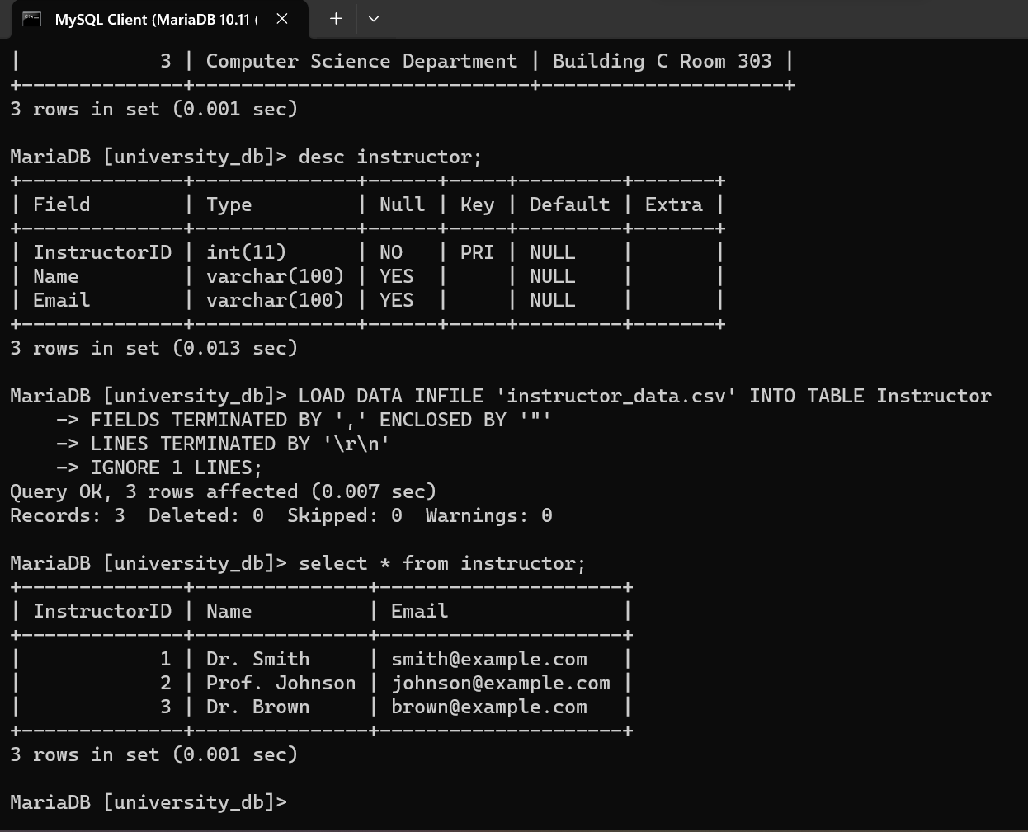

**DEPARTMENT**

# Sample data for Department entity

department_data = [

['DepartmentID', 'Name', 'Location'],

[1, 'Mathematics Department', 'Building A, Room 101'],

[2, 'History Department', 'Building B, Room 202'],

[3, 'Computer Science Department', 'Building C, Room 303']

]

# Writing data to Department CSV file

LOAD DATA INFILE 'department_data.csv' INTO TABLE department

FIELDS TERMINATED BY ',' ENCLOSED BY '"'

LINES TERMINATED BY '\r\n'

IGNORE 1 LINES;

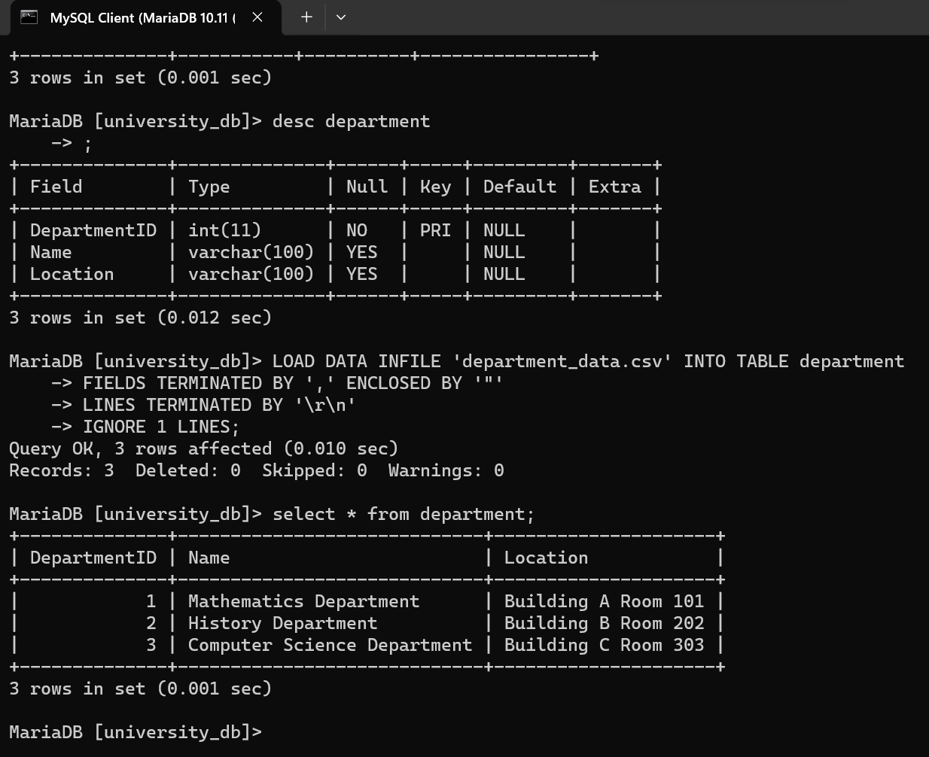

**Select Statements:**

SELECT * FROM students;

SELECT * FROM course;

SELECT * FROM enrollment;

SELECT * FROM instructor;

SELECT * FROM department;